**ST.XAVIER’S COLLEGE**

MAITIGHAR, KATHMANDU



Computer Graphics

Assignment #3

Submitted By:

Aabhash Dhakal

013BSCCSIT001

2nd year/ 4th semester

Submitted to:

|  |  |
| --- | --- |
| Er. Anil K. Sah  Lecturer  Department of Computer Science |  |

**STATEMENT**

Write a program to draw a line using DDA algorithm in C++ builder.

­

**SOURCE CODE**

//---------------------------------------------------------------------------

#include <vcl\vcl.h>

#pragma hdrstop

#include "DDA_Algo.h"

//---------------------------------------------------------------------------

#pragma resource "*.dfm"

TForm1 *Form1;

int i;

int x2, x1, y2, y1, dx, dy, m;

//---------------------------------------------------------------------------

//---------------------------------------------------------------------------

void __fastcall TForm1::X1Change(TObject *Sender)

{

x1 = StrToInt(X1->Text);

}

//---------------------------------------------------------------------------

void __fastcall TForm1::X2Change(TObject *Sender)

{

x2 = StrToInt(X2->Text);

}

//---------------------------------------------------------------------------

void __fastcall TForm1::Y1Change(TObject *Sender)

{

y1 = StrToInt(Y1->Text);

}

//---------------------------------------------------------------------------

void __fastcall TForm1::Y2Change(TObject *Sender)

{

y2 = StrToInt(Y2->Text);

}

//---------------------------------------------------------------------------

void __fastcall TForm1::Button1Click(TObject *Sender)

{

m = (y2 - y1) / (x2 - x1);

for ( i = x1; i<= x2; i++)

{

if (m<=1)

{

dx = 1;

dy = m + dx;

}

else

{

dy = 1;

dx = dy/m;

}

}

x1 = x1 + dx;

y1 = y1 + dy;

Image1->Canvas->Pixels[x1][y1];

}

**OUTPUT SCREENS**

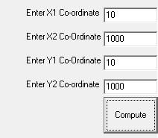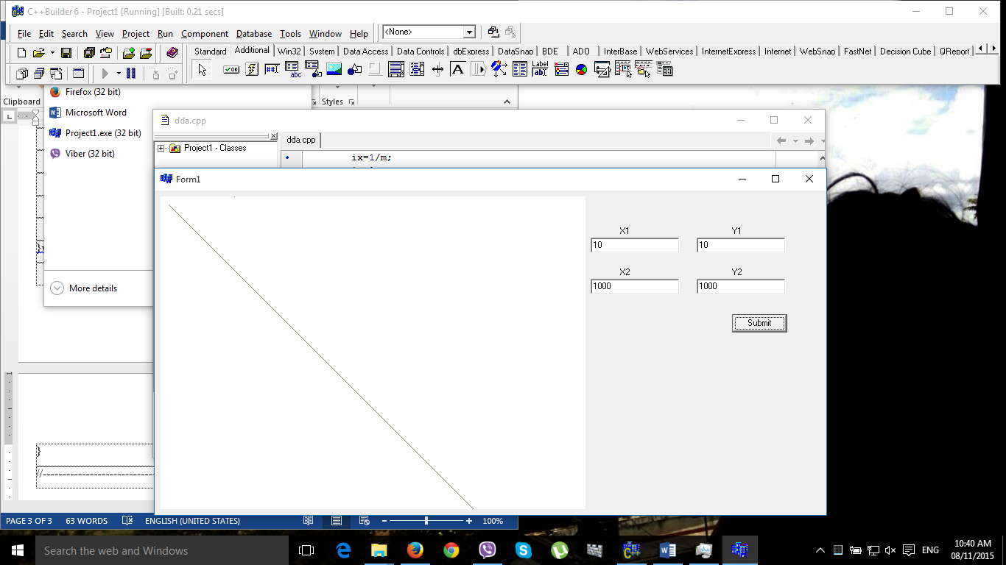

**CONCLUSION**

Hence, a program to draw a line was implemented using DDA algorithm in C++ builder.